# 隐藏状态更新

## 1.（bool判断）让貌似可控的输入变得不可控

合约地址：

0xd6bc92a0f5a2bc17207283679c5ddcc108fd3710

0x24cad91c063686c49f2ef26a24bf80329fb131c7

0xb6f6f6f47e92e517876d30c04198f45a3bc1b281

0xc6389ef3d79cf17a5d103bd0f06f83cf76b14258

0xaa3a6f5bddd02a08c8651f7e285e2bec33ea5e53

0x57684f9059afbf7bb11b07263500292ac9d78e7b

0xe830d955cbe549d9bcf55e3960b86ffac6ef83f1

0x0cfa149c0a843e1f8d9bc5c6e6bebf901845cebe

0x377f64e05c29309c8527022dbe5fbbfa8e40f6dd

0xd8993f49f372bb014fb088eabec95cfdc795cbf6

0x3c3f481950fa627bb9f39a04bccdc88f4130795b

0xe3b0fe57f7de3281579a504dcc3af491afbb23e5

0x99bab102c0a03438bcfd70119f07ee646db26ddf

0x8d056569b215c8b56e4b3a615dac425d8d2352a4

0x7b3c3a05fcbf18db060ef29250769cee961d75ac

0x062e659a3c8991bc1739e72c68edb9ac7b5a8ca7

0x11f4306f9812b80e75c1411c1cf296b04917b2f0

0x1dabd43e0f8a684a02712bcd767056e25026061c

0xaf531dc0b3b1151af48f3d638eeb6fe6acdfd59f

0x3597f78c7872db259ce023acc34511c7a79f42e3

0x75658ed3dba1e12644d2cd9272ba9ee888f4c417

0xabcdd0dbc5ba15804f5de963bd60491e48c3ef0b

0xaa4fd1781246f0b9a63921f7aee292311ea05bf7

0xae3bf0f077ed66dda9fb1b5475942c919ef3bb0d

0x611ae0be21a9c0ab284a4a68c8c44843330072a7

0xd87eaad7afb256c69526a490f402a658f12246fd

0x7fefc8bf6e44784ed016d08557e209169095f0f3

0x0595d187cac88f04466371eff3a6b6d1b12fb013

0x64669148bca4f3d1216127a46380a67b37bbf63e

0x75041597d8f6e869092d78b9814b7bcdeeb393b4

0xb49b1dddf1b3d6e878fd9b73874da7ab0da7e004

0x6f905e47d3e6a9cc286b8250181ee5a0441acc81

0xcb71b51d9159a49050d56516737b4b497e98bb99

0x197803b104641fbf6e206a425d9dc35dadc4f62f

0x4d200a0a7066af311baba7a647b1cce54ae2f9a5

0x4876bca6feab4243e4370bddc92f5a8364de9df9

0x2cc8e271f11934f5fa15942dfda2b59432c2e0f3

0xc304349d7cc07407b7844d54218d29d1a449b854

0xc5ce9c06a0caf0e4cbd90572b6550feafd69b740

0xbae339b730cb3a58eff2f2f2fa4af579332c3e1c

0x2e4eb4585cb949e53212e796cef13d562c24374b

0x2fe321bbb468d71cc392dd95082efef181df2038

0x7ffc2bd9431b059c509b45b33e77852d47de827d

0xaded0438139b495db87d3f70f0991336df97136f

0x34bc4f174c027a68f94a7ea6a3b4930e0211b19d

0x26ae986bfab33f4cbadec30ea55b5eed9e883ecf

0xefbfc3f373c9cc5c0375403177d71bcc387d3597

0x53018f93f9240cf7e01301cdc4b3e45d25481f73

0x2634baad203cba4aa4114c132b2e50a3a6027ff9

0x6594ac0a2ba54885ff7d314eb27c9694cb25698b

0xaec8162438b83646518f3bf3a70b048979f81fab

0xbc272b58e7cd0a6002c95afd1f208898d756c580

0xbf5fb038c28df2b8821988da78c3ebdbf7aa5ac7

0xb38beba95e0e21a97466c452454debe2658527f7

0x13c547ff0888a0a876e6f1304eaefe9e6e06fc4b

0x8bce9d720745b93c58c505fc0d842a7d9cd59697

0x8d4eb49f0ed7ee6d6e00fc76ea3e9c3898bf219d

0x265c91539255a96e1005a0fd11ca776c183d04f5

0x8bbf2d91e3c601df2c71c4ee98e87351922f8aa7

0x686847351a61eb1cae8ac0efa4208ff689fd53f2

0x6ce3fef99a6a4a8d1cc55d980966459854b3b021

0xd0981f1e922be67f2d0bb4f0c86f98f039dd24cc

0xc1d73e148590b60ce9dd42d141f9b27bbad07879

0x930dfbdc5e9f1984a8d87de29d6a79fbb2bb7b32

0x0e8f2803fa16492b948bc470c69e99460942db2b #既有bool判断，也有非bool判断

0x448fcea60482c0ea5d02fa44648c3749c46c4a29

0x68af0f18c974a9603ec863fefcebb4ceb2589070

0xf3f3dd2b5d9f3de1b1ceb6ad84683bf31adf29d1

0xef75f477126d05519d965d116fc9606e60fc70a8

0x9bdb9d9bd3e348d93453400e46e71dd519c60503

0xb91a6c5c6362b10db6440d690e5391bb1eabe591

0x90302710ae7423ca1ee64907ba82b7f6854a5ddc

0x5dac036595568ff792f5064451b6b37e801ecab9

（1）重要特征：

bool变量、反转赋值、要求bool条件。

要求bool条件，可以直接进行“单变量判断”、“！单变量”、“require(单变量)”。

函数之间存在依赖关系,这个可以看CFG图。

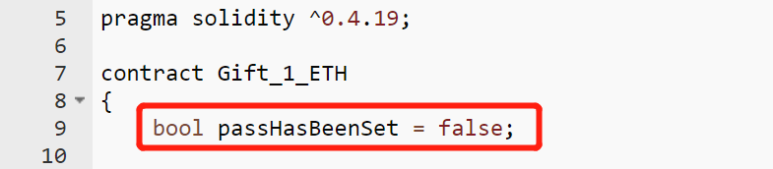

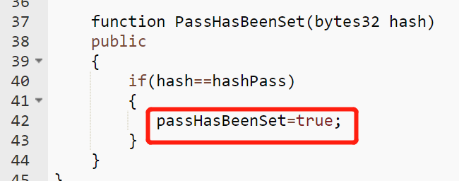

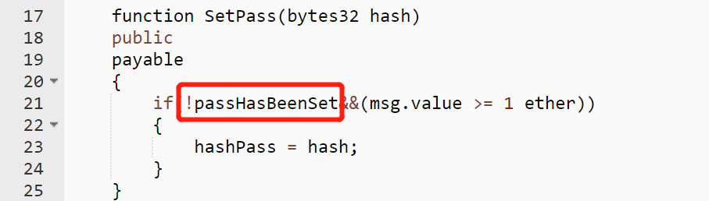

使用elither获取一下cfg：本机查找Gift_1_ETH目录。

## 2.（以修饰符的形式进行条件判断）先转账再执行函数代码

合约地址： （-----honey_badger认为这些不是蜜罐，但我觉得是） --？（再考虑）

0xed4fd2e53153b8bfd866e11fb015a1bc4a0e9655

0x1efd5dc066eb56d4db7e2ff38843c8bf8aa59168

0x38321bbb97a3541bb3913c12201b35d504f7af39

0xfb0513602b08ede66c28c128ece6a2f11161f17f

（1）重要特征：

其实跟1.是本质是一样的，只不过有点唬人。

## 3. (非bool的条件判断)

合约地址：（跟1.的本质也是一样的） --- 75个

0x735906d7ab237eeea06f4af86795bb4e0ec199e0 #responseHash

0xa630823bd70ab8e8e2d6e62089d3837db1887bf6

0x2e0794073ec7b08e40d80a41599bb31df042e4e5

0xde82658c23f034d71827c215fdfbce0d4e248ccd

0x4c4757b23526ba13876f8ef3efe973618266e3e8

0x878e6c6f9a86a1e5d313e7b872ccd109135e91b4

0xbd53a4db4003c59070abbfa4e6c31afbf0b26843

0x96fa4b2bebbbc9ffdb7d64ed18058de27680752c

0x064656852581472f9b315fea4730fe18fb7c579a

0x1237b26652eebf1cb8f59e07e07101c0df4f60f6

0x704079e823e42a936bbaac5163434c2515473836

0xed55fb58ea9de1f484addcc970463218b4d89cfe

0xff45211ebdfc7ebcc458e584bcec4eac19d6a624

0x85044611b5954739dbde0ccb9aae6bb18e38e38b

0x137e531680b5d1f5645cd73a450323f1645d5034

0xf0344800bd3ffa687e4d780357961b28995a5f46

0xed710216da4b1416a78768790ca9aa3633ca110f

0xdda2044b39fdb4db77ac085866179c548e5d0f15

0x590d1d5ba0feb249d42c527ae21d12f2e5768a87

0xc034cf94f7ced9c968cc75210d1b5ddaccacfbf4

0xcaa7b8aa3bc78dda98af8fee1390f34e756a5f55

0xacfc9577583ded00ae53ae79a0346cca4655c0bb

0xc77081641129a028d622f85671ea172ac5595938

0xce6b1aff0fe66da643d7a9a64d4747293628d667

0x0684a256b8a6434cf10ee81bc1bcdcbba3365daa

0x4a73d9fe078fa67601047f88c3e6c270602e5709

0x3b048ab84ddd61c2ffe89ede66d68ef27661c0f2

0xfac1c7270bc5b0664e27e7f2e82281d564aedf4e

0xa9aebbf67433e3e8206af6fc2ddd99ff8e7cc137

0xa48a36d94024f861b453267468b9096e4a3eb8be

0xe3d085b7bdf97c6d003abcec2003b9c5b120d616

0x70bf9df6967dc96156e76cc43b928a7ef02e159a

0x16aae4b322501c339ed31a41fb915ae305528585

0x1fbf025ad94dde79f88732f79966a9a435f2772f

0x4ca675d62a05c451555c93e456f902bd3e423586

0xcea86636608bacb632dfd1606a0dc1728b625387

0xc7e454770433c071dd1863eeb27fb7e1adbd3361

0x2b98b39d39914b3aad05dd06a46868507156400d

0x19d0321ba91ed5edec4afe1da158a6b06bba03f0

0xb5c424cd005cd1ccc155654b551c4453346e0718

0x159d2829613b0fe363e462b218c695c6eae0a5e1

0xb19117892e2b2aaa418e75f61d7d1c05f86b66bd

0x8a36f3e0da7b36fd22fcf2844c21e812279372ac

0x40ef62929748b3e045fd2036322880ef486e4454

0x4aec37ae465e1d78649aff117bab737c5fb4f214

0xbb51397fb8d3b91a08eff3c34d5c869c1d149ec5

0x5ccfcdc1c88134993f48a898ae8e9e35853b2068

0x3caf97b4d97276d75185aaf1dcf3a2a8755afe27

0xc1574ab95106621686d6e480f378d79c0442fe33

0xaea5418057d0e37a6e69e588e7f393e946846d62

0x36d5d7262784130de564e99f5c2eab2aa0484bce

0xc78f0fdfb708689cbe6629175b66958eaa89e7d0

0x3668eba58190c7bb2d63cb484467ff0a42fb3367

0x4bc53ead2ae82e0c723ee8e3d7bacfb1fafea1ce

0x52682a037a8deab04e708055c751556a0840897a

0xa0f9e5283fbf6d735e1e3a0f724ea6cccc13c27a

0x0e35f4f608d4a8fa560595db79cfda02d790777b

0xe1ccb3a5bae6fecdb9b60c0acf94989f48c10742

0x129e719c424a7a6fbdeb7ca3d65186892d54ea8c

0x59434a7b9aeebe94045d3715aa020f6a1d7875ad

0xa379eda47d90fb4bc2dfa54556421ff0f198ca47

0x6fc1ee575e9023aea1c45b4dfc9acf603ea9f63f

0x7bf5a0802a5eb74883806e60600290f53da339e1

0x5e521b660fe8ac575f1d7201f2237724ee531f1d

0xcac14364754336d9759caafddef8d662dcca06a0

0xaee056c6c1071512657f094af550d1af74db0622

0x6e6f819299e7809ce744f37fae9f84fe38d95f1c

0x5b39afa22a9debd9247bf84b68a79b8736c2ba4e

0x2ad6bdedf16b32a925ba293ee07f9b3c1c5ab266

0x3fab284a3cd0a6d88d18d0fda4bc1a76cdacd68a

0x46de9ef59a51388961bfbe45fb89bedbdfaa32ac

0x7c52974b6eb8af0ddf874b3c4e03aa9a791d9632

0x349d9314154ef0999facdbbcea2d9737b0529570

0x51ae2f91619246ad3a20f4e76f3323a836bde6a5

0x06c2452bcb4c1c1a046c520ffbad41fb8f48442b

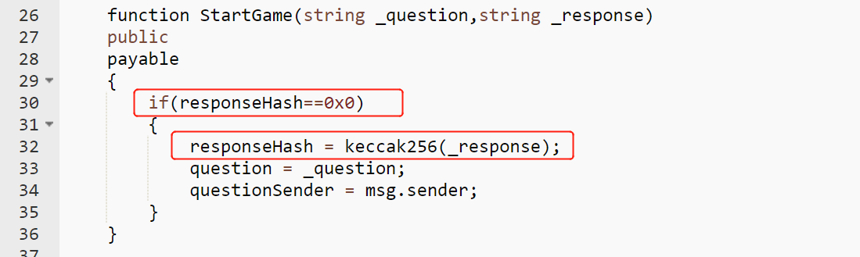

## 4. 被honey_badger paper认为不是蜜罐的

合约地址：（没看懂）

0xb5aff01f3e820735fac9abb594dc9993cb9e5bd2

0x286bbee3f20f1702e707e58d33dc28a69e7efd4e #感觉像蜜罐，但是没看懂

0xb389327f8325d9568826b0f3ca63ef613687cfab

0x175744fb0849584129fa3d0e6350c00206d95d2f

0x85bc00724203d53536072b000c44a2cc16cd12c5

0xdfe06d5a4534fbe955eebe8a4908ef596763c2a4

0x03209bde47da583547c17c47e7ca74bfa3dfb404

0x0ffb3f4605dd9f01de1a06052b7687418a9d82ee

0xb85a54944b58342b07887942e6f530f616479efd

0xa1477980b4fbbe5a1eca65e2aee84bec79c133f9

0xb919b2903e07293bc84372471a7081ecb69e8d36

0x3b0e5a2a318616b1673b0bc7a91dd7c6d85b7e56

0x95be22039da3114d17a38b9e7cd9b3576de83924

0xefc9ba892c557ff541947116040cbb669b5c0a35

0xc8b2c33a45ce83d19da15a58d1d1ddb2738506bf

0x75890afea0658ed67e145df17948c8fceed0affa

0x807a3ef8a8dbdd7fc9863df695bbe8691e450e8e

0xc90233644d2eeb37a7ec641072c85ad272ef2feb

0xedc77f347a7dbdba2319e86ef5681535f8da75e0

0x7c05c837f7a84dced69ae94f8649bbc3897d2b31

0x07ec6c3159c2336ba36ab41f73411f8fee430470

0x7a2ac9691ce2fcffb9777311c14a82a6aec7e639

0x8cc5d9de2c8df87f2d40d84aa78049ea6e61f973

0xf6b55acbbc49f4524aa48d19281a9a77c54de10f

0xf331f7887d31714dce936d9a9846e6afbe82e0a0

0x7409bac00c479b0003651cc157a72d1a227eccfb

（其实我也没看懂？？？）

## 5. 我是真没看出来有陷阱：（我认为不是蜜罐）（honeyBadger认为是蜜罐）

0xb620cee6b52f96f3c6b253e6eea556aa2d214a99